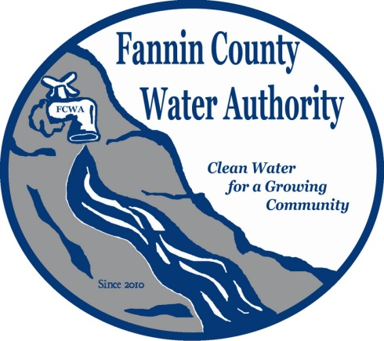
Fannin County Water Authority
Regular Monthly Meeting
Commissioners Meeting Room
April 19, 2017, 2:00 P.M.

Anita Weaver called the meeting to order 2:00 P.M.
Members present were Anita Weaver, Chairwoman, Larry Chapman, Vice-Chairman, Zack Ratcliff, Larry Atkins, David Falls and Kay Kendall, Secretary. Jackie Self was absent. A quorum was present.
A motion was made by Kay Kendall to approve the minutes from the Regular Monthly Meeting of the Water Authority held March 15, 2017. Larry Chapman seconded the motion. The motion passed unanimously.
Marnie Mashburn, Administrative Assistant supplied a copy of the Budget vs. Actual report to all Board Members. Collections are being monitored closely with only a couple issues. Water sample bottles were received for the Copper and Lead testing for the Riverwalk on the Toccoa project area (WSID 1110126). Copper and Lead testing is done twice a year for each water system. The total balance owed to Fannin County is $89,254.84. There is an upcoming, interest only payment due June 20, 2017 to the USDA-RD (United States Department of
Agriculture – Rural Development) in the amount of $60,515.00 and then regular monthly payments will begin on July 20 in the amount of $7225.00, ending in June 2054. Thirteen customers have signed up for text alerts from the FCWA and 24 customers are signed up for Auto-pay.
Dusty Stancil with T. Stanco, Inc. reported that they are short on pipe which is on order. Once the pipe arrives, the project should be complete within two weeks.
Kurt McCord with Carter & Sloope Consulting Engineers reported that plans for River Crest are almost complete and will be submitted to EPD within the next two weeks. He also reported that we’ve obligated $655,000.00 for the GEFA project so far which is still lower than what was initially projected.
A motion was made by Larry Chapman to appoint Lynn Doss - FCWA attorney, Carter & Sloope - FCWA Engineering Firm and R. L. Jennings – FCWA Accounting Firm for 2017. Larry Atkins seconded the motion. The motion passed unanimously.
A motion was made by Larry Atkins to approve the Disconnect/late fee policy presented by Lynn Doss last month. Kay Kendall seconded the motion. The motion passed unanimously.
Anita Weaver reported that the workshop held this morning was very productive.
Larry Atkins reported that current rates set by the FCWA were compared to other water utility companies and a rate proposal was drafted for approval. He explained that there will be one base rate for all customers of $38.00. Results of research showed that the average family uses 4000 to 5000 gallons of water per month. Since the rate charged to the FCWA was raised, this will be passed on to the customer. The new Residential Unit Rate is:
0 – 5000 gallons charged at $5.00/1000 gallons and 5001 and over charged at $7.00/1000 gallons.
The Irrigation rate was also adjusted. A summary was added to the top of the proposal to further explain reasons for the changes. The changes will be effective beginning in June 2017.
A motion was made by Larry Atkins to accept the rate change proposal. Larry Chapman seconded the motion. The motion passed unanimously.
A motion was made by Larry Chapman to repay Fannin County for Salaries and Fringe Benefits for January – March 2017. David Falls seconded the motion. The motion passed unanimously.
John Thompson reported that they plan to build a church on Blue Bird Road and would like to know the possibility of obtaining water from the FCWA. He also explained that this is preliminary and they are also looking at a possible well. The church project will be complete in approximately one and a half to two years. Larry Chapman reported that he has already started to look at this area and would like to have Carter & Sloope start an investigation.
A motion was made by Larry Chapman to have Carter & Sloope begin an investigation of Blue Bird Road and determine if it is a feasible project. Zack Ratcliff seconded the motion. The motion passed unanimously.
A motion was made by Kay Kendall that the meeting adjourns. Zack Ratcliff seconded the motion. The motion passed unanimously.

_______________________________, Anita Weaver, Chairwoman

_______________________________, Kay K. Kendall, Secretary

