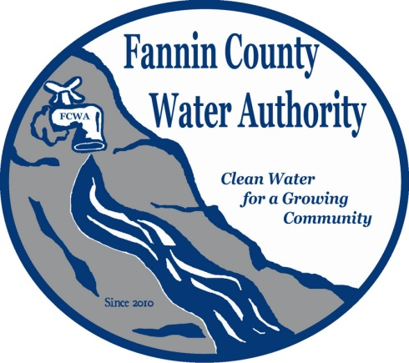
Fannin County Water Authority
Regular Monthly Meeting
Commissioners Meeting Room
August 16, 2017, 2:00 P.M.

Anita Weaver called the meeting to order 2:00 P.M.
Members present were Anita Weaver, Chairwoman, Larry Chapman, Vice-Chairman, Zack Ratcliff, Larry Atkins, David Falls, Jackie Self and Kay Kendall, Secretary. A quorum was present.
A motion was made by Larry Chapman to approve the minutes from the Regular Monthly Meeting of the Water Authority held July 19, 2017. Zack Ratcliff seconded the motion. The motion passed unanimously.
Marnie Mashburn, Administrative Assistant supplied a copy of the Actual vs. Budget report to all Board Members. Collections are being monitored closely with few issues. There’s one new sign-up within the Riverwalk on the Toccoa Subdivision and a certified letter was sent to past due account within the My Mountain Subdivision. An approval letter was received from Georgia EPD for the River Crest Lane extension.
Ed Hawkins, Field Supervisor reported that the back-up pumps for the My Mountain jockey pump station have arrived and parts were ordered from HD Supply Waterworks to complete the installation.
Carter & Sloope Consulting Engineers prepared an advertisement for the bi-annual labor contract. Kurt went on to explain that this is needed for times when Ed Hawkins, Field Supervisor for the Fannin County Water Authority is unable to complete a job due to injury or needs help due to the size of the job. With a labor contract in place, the FCWA will no longer have to bid-out small extensions.
A motion was made by Larry Chapman to run the Ad for the bi-annual labor. Larry Atkins seconded the motion. The motion passed unanimously.
Kurt McCord with Carter & Sloope Consulting Engineers reported that they are working on preparing information for the final draw from GEFA. Another map was prepared for the Blue Bird Road service area and discussions of the many options for this installation continued between The FCWA Board, Lynn Doss and Carter & Sloope. Kurt explained that their preferred plan includes connections to both the City of Blue Ridge and the City of Morganton water supply, but will also connect to the CDBG service area. If the systems are connected, another Operating Permit will not be required by EPD.
Kurt McCord reported that they completed a feasibility study for the Aska Road Extension which includes the entire length of Aska Road. This extension was broken down into 3 phases: Blue Ridge Service Limits @ Weaver Creek Road to Green Mountain Ct., Green Mountain Ct. to Old Aska Road, and Old Aska Road to Newport Rd. and Black Ankle Creek Rd. He explained that each phase can be completed separately, under separate projects or all three can be included in one project. The line will need to run into the City of Blue Ridge service area to tie-in. Anita Weaver, FCWA Chairwoman suggested that copies of the Future Growth Feasibility Study be supplied to all FCWA Board members so that they may review and discuss at the next Regular Monthly Meeting.
A motion was made by Kay Kendall to pay invoice 70961 from BSI Mechanical Sales and Service in the amount of $5,090.70. Zack Ratcliff seconded the motion. The motion passed unanimously.
A motion was made by Zack Ratcliff to pay invoice 22168 from Carter & Sloope in the amount of $15,342.50. Jackie Self seconded the motion. The motion passed unanimously.

A motion was made by Larry Atkins to pay off the debt owed to Fannin County in the amount of $89,276.87. Zack Ratcliff seconded the motion. The motion passed unanimously.
Larry Chapman, FCWA Vice-Chairman reported that Larry Atkins and himself met with Lon Dillard, a representative of Byers Well Drilling to discuss “The Heights of Cashes Valley”. He also reported that he doesn’t agree with how the letter is written. He said instead of addressing it “To whom it may concern”, it should be addressed directly to the person or company who has applied for the Permit. It should not be transferable without consent from the FCWA. It should also have conditions attached to the letter. He suggested that the FCWA form a committee including himself, David Falls and Larry Atkins to work with Carter & Sloope and Lynn Doss to develop a letter to be used for future requests.
Larry Atkins, FCWA Board Member explained that Byers Well Drilling did notify the FCWA of their request for the letter regarding “The Heights of Cashes Valley”. This system is an older system and has been permitted in the past. The original owner is Brian Graham and he sold the well to Byers Well Drilling, who will take over operations. They want to be a proprietor and are seeking this letter so that they can achieve this. Before signing off on this letter, the FCWA would like to include some ordinances and standards. Larry Chapman added that the FCWA will be able to account for new systems coming into the county and could obtain more information such as plans and testing.
A motion was made by Jackie Self to form a committee consisting of Larry Chapman, Larry Atkins and David Falls to work on a letter to be used for future requests. Zack Ratcliff seconded the motion. The motion passed unanimously.
Kay Kendall, FCWA Secretary clarified that boil-water and similar alerts are only issued by EPD. Ed Hawkins confirmed that if a problem was discovered, he would notify EPD and they would be the initiators of the alert.

Chuck Burden, a Riverwalk on The Toccoa resident and P.O.A. Member reported that there’s still a few repairs that need to be made to the roads within the Subdivision. Anita Weaver reported that bids will be received and repairs made as soon as possible.
A motion was made by Kay Kendall to go into executive session to discuss Personnel. Zack Ratcliff seconded the motion. The motion passed unanimously.
Coming out of executive session, no decisions were made.
A motion was made by Zack Ratcliff that the meeting adjourns. Larry Atkins seconded the motion. The motion passed unanimously.

_______________________________, Anita Weaver, Chairwoman

_______________________________, Kay K. Kendall, Secretary

