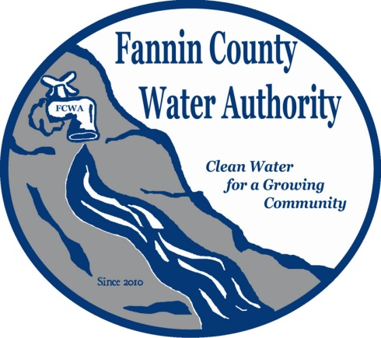
Fannin County Water Authority
Regular Monthly Meeting
Commissioners Meeting Room
July 19, 2017, 2:00 P.M.

Anita Weaver called the meeting to order 2:00 P.M.
Members present were Anita Weaver, Chairwoman, Larry Chapman, Vice-Chairman, Zack Ratcliff, Larry Atkins, David Falls and Kay Kendall, Secretary. Jackie Self was absent. A quorum was present.
A motion was made by Zack Ratcliff to approve the minutes from the Workshop held on June 21, 2017. Larry Atkins seconded the motion. The motion passed unanimously.
A motion was made by Zack Ratcliff to approve the minutes from the Regular Monthly Meeting of the Water Authority held June 21, 2017. Larry Atkins seconded the motion. The motion passed unanimously.
Marnie Mashburn, Administrative Assistant supplied a copy of the Actual vs. Budget report to all Board Members. Collections are being monitored closely with few issues.
Anita Weaver, Chairwoman reported that the Service Delivery Strategy Agreement would need to be approved in this meeting per Lynn Doss. Marie Woody, Land Development Head explained that the FCWA will need to write a resolution and approve the resolution to go with the Service Delivery Map and attach to the Delivery Strategy Agreement. Anita Weaver reported that the FCWA will have a Special Called Meeting once they have had time to review with Lynn Doss.

Matt Smith with Carter & Sloope reported that there was an issue with the holding tank located in the My Mountain Subdivision. The signal to turn the pumps on and off use the AT&T tower. The pumps were turned on when the signal went down which caused the pumps to stay on. They will work on a fail- safe back-up, such as a timer. He also reported that he is working on delegations for the FCWA to approve small extensions themselves instead of going through EPD. EPD approval has not been received yet for the River Crest Extension. Typically, 45 days is the wait period for EPD approval on small extensions.
Ed Hawkins, Field Supervisor reported that the jockey pump signal was first set up with Verizon, but the signal was not strong enough. He reported that this has never happened before.
Matt Smith reported that the Master Plan is evolving into a more task oriented vs. a Master Plan. Because the way the FCWA system is set up it will more of a task breakdown plan.
A motion was made by Kay Kendall to approve payment of 2nd Quarter Salaries and Fringe Benefits back to Fannin County. Larry Atkins seconded the motion. The motion passed unanimously.
A motion was made by Kay Kendall to adopt the Preliminary Standards developed for the FCWA by Carter & Sloope. David Falls seconded the motion. The motion passed unanimously.
Anita Weaver announced that they will go into executive session. Coming out of executive session, no decisions were made.
A motion was made by Kay Kendall to reimburse each authority member who attends each monthly meeting at a rate of $100.00 per month per member and reimburse the Chair at a rate of $150.00 per month in lieu of each individual submitting a monthly expenditure report. This is common practice with water authorities throughout the state. Larry Chapman seconded the motion. The motion passed unanimously.
A motion was made by Zack Ratcliff that the meeting adjourns. Larry Atkins seconded the motion. The motion passed unanimously.

_______________________________, Anita Weaver, Chairwoman

_______________________________, Kay K. Kendall, Secretary

