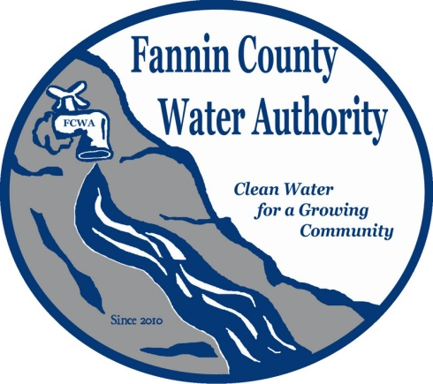
Fannin County Water Authority
Regular Monthly Meeting
Commissioners Meeting Room
March 15, 2017, 2:00 P.M.

Anita Weaver called the meeting to order 2:00 P.M.
Anita Weaver, Chairwoman welcomed new Board Member, David Falls who will finish the term of Tim Smith ending in March 2018. He will bring much value to the Fannin County Water Authority.
Members present were Anita Weaver, Chairwoman, Larry Chapman, Vice-Chairman, Zack Ratcliff, Larry Atkins, Jackie Self, David Falls and Kay Kendall, Secretary. A quorum was present.
A motion was made by Kay Kendall to approve the minutes from the Regular Monthly Meeting of the Water Authority held February 15, 2017. Zack Ratcliff seconded the motion. The motion passed unanimously.
Marnie Mashburn, Administrative Assistant supplied a copy of the Budget vs. Actual report to all Board Members. Collections are being monitored closely with only a couple issues. The two certified letters were received by the customers, but they did not contact the office. Employee wage and fringe reports will be supplied by Fannin County quarterly instead of once per year. Customer Deposits were billed out to the customers in the Riverwalk on the Toccoa Project area.
Lynn Doss with Doss & Associates stated that there is procedure for attorneys to handle bad debt and it will be addressed.
Anita Weaver reported that a customer (Steve Lamb) with property located @ Mercury Lane and Curtis Switch requested to be released from the water service contract. He already paid the tap fee in the amount of $825.00 and is located approximately 2000 feet away from the last service on Mercury Lane.
A motion was made by Larry Chapman to refund the tap fee and release Steve Lamb from his water service contract. Zack Ratcliff seconded the motion. The motion passed unanimously.
Zack Ratcliff reported that Ed Hawkins has crossed the creek on Cross Creek Road within the Riverwalk on the Toccoa project area.
Kurt McCord with Carter & Sloope reported that the design for River Crest is 50% complete. He also reported that an air pocket was discovered in the My Mountain jockey pump which has not yet caused any problems, but he suggests installing an air-release valve to avoid any problems to come. This will cost approximately $600.00 for parts. The 3rd draw from GEFA (Georgia Environmental Finance Authority) is being prepared and the construction portion is still under budget. T. Stanco Inc. should finish the construction within the week and then will work on the few remaining punch list items. Engineering certificates will be issued to EPD (Environmental Protection Division) and then testing of the water will need to begin.
Anita Weaver reported that she spoke with Appalachian Water approximately 2 weeks ago and informed them that the FCWA is still interested in purchasing their system within the Bear Tracks Subdivision. She also invited them to today’s meeting to meet the offer deadline.
Kay Kendall, Secretary reported that the offer to purchase the water system in Bear Tracks was good until today and therefore the FCWA will not be obligated to purchase after today. Larry Atkins confirmed that the offer is withdrawn.
Anita Weaver reported that the bank account to hold Customer Deposits is now active. The length of time deposits will be held will need to be determined. Lynn Doss is working on a disconnect/late fee policy.
Lynn Doss reported that a draft of the disconnect/late fee policy was emailed to all FCWA Board Members for review. She also explained that Larry Chapman suggested charging a Reconnect Fee also. She also suggested that the FCWA start looking at an online bill pay system.
Kay Kendall confirmed that with a Reconnect Fee, the customer will be charged once for the disconnection and then again to reconnect. She also suggested changing the deadline time of day to pay from 4:00 p.m. to 2:00 p.m. allowing more time for staff to complete duties.
A motion was made by Kay Kendall to change the deadline time to pay and to adopt the Reconnect Fee of $75.00. Larry Chapman seconded the motion. The motion passed unanimously.
A workshop for the FCWA Board was scheduled for April 19, 2017 @ 8:00 a.m. to discuss policies and guidelines.
Chuck Burden, a member with the Riverwalk on the Toccoa HOA reported that there are still some issues that need attention on the jobsite such as stumps that are sticking up too high. Kurt McCord will look at these issues further to make sure attention is given to problem items. He also warned that by pulling stumps out of the ground might cause more problems with other underground utilities. Anita Weaver will receive suggestions from Chuck as to what type of Shrubbery will be planted, if any. Marnie Mashburn suggested a punch list with a deadline, like the one in My Mountain be put in place.
A motion was made by Zack Ratcliff to go into Executive Session to discuss real estate. Anita Weaver seconded the motion. The motion passed unanimously.
Coming out of executive session, no decisions were made.
A motion was made by Larry Chapman to purchase an easement from Margaret Ford. Larry Atkins seconded the motion. The motion passed unanimously.
A motion was made by Jackie Self to make Anita Weaver, Kay Kendall, Larry Chapman and Marie Woody signers for the new account to hold customer deposits. Zack Ratcliff seconded the motion. The motion passed unanimously.
A motion was made by Kay Kendall that the meeting adjourns. Larry Atkins seconded the motion. The motion passed unanimously.

_______________________________, Anita Weaver, Chairwoman

_______________________________, Kay K. Kendall, Secretary

