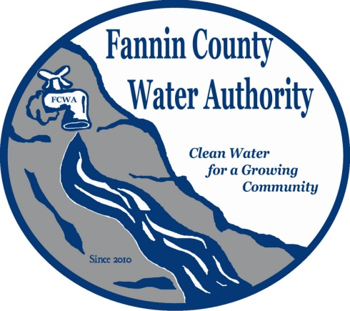
Fannin County Water Authority
Workshop - Teleconference
Commissioners Meeting Room
May 17, 2017, 1:00 P.M.

Anita Weaver called the meeting to order 1:00 P.M.
Members present were Anita Weaver, Chairwoman, Larry Chapman, Vice-Chairman, Zack Ratcliff, Larry Atkins, Jackie Self, David Falls and Kay Kendall, Secretary. A quorum was present.
Beth Jones with the Chattanooga Area Council of Government joined the workshop via speaker phone. She explained that they provide staff to the SEIDA (Southeast Industrial Development Association) Program which is a regional economic development program funded by TVA power distributors. She also said they are very similar to and work very closely with the Northwest Georgia Regional Commission. Tennessee doesn’t have the same planning requirements as Georgia and is more focused on infrastructure development rather than strategic planning. She reported that they write for many grants for local communities and work closely with regional utilities. In a year’s time, $15,000,000.00 in infrastructure work may be in progress; some being just applied for and others further along. Grants for infrastructure can be obtained for all of Fannin County.
Beth discussed many types of loans and grants including CDBG (Community Development Block Grant), Rural Development, ARC (Appalachian Regional Commission), Georgia One dollars and TVA.
Beth explained that TVA funding is an application process and is specifically for industrial growth and should create more jobs.
A resort or a planned community development could qualify as an economic development, but you would have to make sure that it will benefit the public. ARC is more open to this type of loan than the others mentioned. ARC requires a pre-application in the spring and will invite a full-application if they feel that the project will qualify. Projects will usually have to be completed within 24 months, but extensions may be requested. They also may require 50/50 match and do not want Federal Money used to match Federal Money. SPLOST money is considered local money and can be used. Lynn Doss with Doss & Associates asked if the developer could pay the match? Beth reported that this would be private investment which is favorable.
The SR-2 Readiness mini-grant is another source which will give approximately $5000.00 for a feasibility study or engineering work or something similar.
Beth Jones plans to meet with the FCWA in the morning on July 19, 2017.

_______________________________, Anita Weaver, Chairwoman

_______________________________, Kay K. Kendall, Secretary

