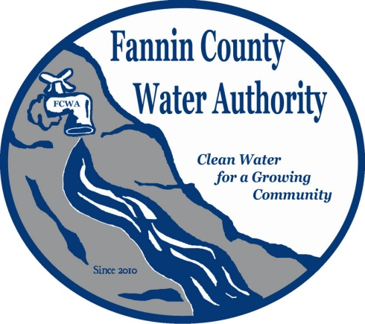
Fannin County Water Authority
Regular Monthly Meeting
Commissioners Meeting Room
May 17, 2017, 2:00 P.M.

Anita Weaver called the meeting to order 2:00 P.M.
Members present were Anita Weaver, Chairwoman, Larry Chapman, Vice-Chairman, Zack Ratcliff, Larry Atkins, Jackie Self, David Falls and Kay Kendall, Secretary. A quorum was present.
A motion was made by Larry Atkins to approve the minutes from the Regular Monthly Meeting of the Water Authority held April 19, 2017. Larry Chapman seconded the motion. The motion passed unanimously.
Marnie Mashburn, Administrative Assistant supplied a copy of the Budget and the P&L report out of QuickBooks to all Board Members. Collections are being monitored closely and all disconnected services are paid in full. The Millholland Connection water loss report was supplied to all FCWA Board Members.
Ed Hawkins, Field Supervisor reported that all meters and taps are installed on Cross Creek Road within the Riverwalk on Toccoa Subdivision.
Kurt McCord with Carter & Sloope Consulting Engineers reported that T. Stanco, Inc. will complete all punch-list items soon and will then submit their final pay request. He also reported that there will be some unused funds that could be returned to GEFA. The unused funds can only be used for areas that already have environmental clearance, such as Bear Tracks. The FCWA can decide to close out the Riverwalk on the Toccoa Project.
A motion was made by Larry Chapman to proceed with the Robert Miller Extension. Kay Kendall seconded the motion. The motion passed unanimously.
Marnie Mashburn reported that Evan Peck, a property owner on River Crest Lane already signed up and paid the tap fee of $1625.00. His property is located 500 feet from the planned waterlines which will end at the intersection of Robert Miller Lane and River Crest Lane.
Kurt McCord reported that EPD approval will be needed to extend the line along River Crest Lane. He also reported that this should take approximately one to two months. GEFA funds cannot be used for River Crest Lane because it was not part of the initial environmental clearance area. A two-inch line could be installed and would have the capacity to serve and provide fire protection to all the property owners on River Crest Lane.
Chuck Burden, a Riverwalk on the Toccoa Homeowner reported that the growth in the subdivision is growing rapidly with 6 new homes built just last year.
Larry Chapman, Vice-Chairman reported that if the FCWA runs a line to the end of River Crest Lane, the property owners will likely connect to the service.
A motion was made by Kay Kendall to have Kurt McCord get EPD approval for the River Crest Lane extension and if approval is obtained, extend the line to the end of River Crest Lane. Larry Atkins seconded the motion. The motion passed unanimously.
Kurt McCord brought Blue Bird Road cost estimates to the FCWA Board. He explained the first estimate includes the Faith Presbyterian Church and 32 residential homes. It also includes a tie-in with the City of Blue Ridge and connects with the City of Morganton too. Joe Foster owns 12 homes in the service area and is very interested in connecting. The second, less expensive estimate included the Faith Presbyterian Church, 28 residential homes and does not include hydrants or the tie-in to the City of Blue Ridge.
A motion was made by Larry Atkins poll potential customers. Larry Chapman seconded the motion. The motion passed unanimously. Lynn Doss will mail letters.
A motion was made by Jackie Self to pay Carter & Sloope invoices. Kay Kendall seconded the motion. The motion passed unanimously.
A motion was made by Kay Kendall to make payment to USDA (United States Department of Agriculture – Rural Development) in the amount of $60,515.00 due on June 20, 2017. David Falls seconded the motion. The motion passed unanimously.
A motion was made by Kay Kendall to have Carter & Sloope prepare standard specs and standards for new developments. Larry Atkins seconded the motion. The motion passed unanimously.
Kurt McCord reported that movement into the My Mountain Phase 1B will need to be discussed. Anita Weaver will check with the developer and have an update for the next Regular Monthly Meeting.
A motion was made by Zack Ratcliff that the meeting adjourns. Larry Atkins seconded the motion. The motion passed unanimously.

_______________________________, Anita Weaver, Chairwoman

_______________________________, Kay K. Kendall, Secretary

