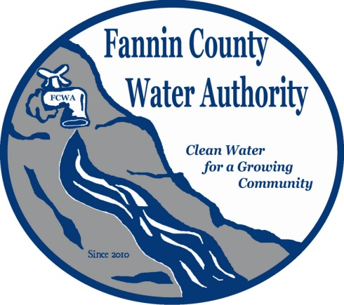
Fannin County Water Authority
Regular Monthly Meeting
Commissioners Meeting Room
September 20, 2017, 2:00 P.M.

Anita Weaver called the meeting to order 2:00 P.M.
Members present were Anita Weaver, Chairwoman, Larry Chapman, Vice-Chairman, Zack Ratcliff, Larry Atkins, David Falls, Jackie Self and Kay Kendall, Secretary. A quorum was present.
Kurt McCord with Carter & Sloope Consulting Engineers opened bids for the Biennial Labor Contract. He explained that this contract for labor is to cover times when Ed Hawkins is unavailable or doesn’t have help to complete tasks. He also went on to explain that this contract will not cover emergencies or labor on financed projects with special funding. Preference will not be given to construction companies based on location. Bids came in at $567,469.00 by Mullins Utility and Contracting, LLC., $580,555.00 by Holloway Trenching LLC. and $451,810.00 by T. Stanco, Inc. Kurt reported that he will bring the bids back to his office and double-check the calculations and quantities.
A motion was made by Jackie Self to approve the minutes from the Special Called Meeting of the Water Authority held August 3, 2017. Larry Atkins seconded the motion. The motion passed unanimously.
A motion was made by Jackie Self to approve the minutes from the Regular Monthly Meeting of the Water Authority held August 16, 2017. Larry Atkins seconded the motion. The motion passed unanimously.
Marnie Mashburn, Administrative Assistant supplied a copy of the Actual vs. Budget report to all Board Members. Collections are being monitored closely with no issues. The new connection at 220 Cross Creek Road within the Riverwalk on the Toccoa Subdivision is complete.
Kurt McCord reported that EPD did not approve the Delegated Review Authority, but the FCWA is welcome to re-apply in one year. He also reported that the final draw for the GEFA Loan was submitted and should be deposited within the next few days.
Lynn Doss with Doss & Associates reported that everything is in place to go ahead with the completion of the River Crest Lane extension.
Carter & Sloope Consulting Engineers recommended tapping onto the City of Blue Ridge waterline at Lakewood to serve Blue Bird Road. Plans include connecting to the Hidden Valley Drive Water System so that a new Operating Permit will not be required. This will be done with most of the remaining SPLOST dollars.
A motion was made by Kay Kendall to approve the Blue Ridge Road Project as presented by Carter & Sloope to be completed with SPLOST dollars. Larry Atkins seconded the motion. The motion passed unanimously.
The Aska Road extension was tabled until a later date. This is a very large project and other projects may be more easily completed before this one.
Hubert Anderson, a resident of the Lake Cove neighborhood in Morganton asked the FCWA Board to consider installing water to a potential 50 new customers. There are 25 to 30 structures already built in the neighborhood for which all are interested in obtaining water per Hubert Anderson. The water has a lot of sediment which prevents drinking, making ice and washing white clothes. The water isn’t as bad for the homes closest to the lake. There is a fire hydrant already located on Lake Cove Drive.

A motion was made by Larry Chapman to authorize Carter & Sloope to start work at the Lake Cove, Deer Hunter and the Forest Service to be paid with the remaining SPLOST dollars. David Falls seconded the motion. The motion passed unanimously.
A motion was made by Kay Kendall to pay invoice 17381 from R. L. Jennings & Associates, PC in the amount of $5,000.00. Larry Chapman seconded the motion. The motion passed unanimously.
A motion was made by Larry Chapman to pay invoices for April ($4,462.50), May ($4,637.50) and June ($7,612.50) from Doss & Associates. David Falls seconded the motion. The motion passed unanimously.
George Bienert, a resident of the Riverwalk on the Toccoa Subdivision thanked Ed Hawkins and Marnie Mashburn for making sure that the roads within the subdivision were temporarily repaired. Anita Weaver reported that Andy Crawford will complete the permanent repairs within the next week.
Larry Atkins, FCWA Board Member reported that he worked with Marie Woody with Land Development to obtain a spreadsheet of building permits filed within the past three years. This will help the FCWA to prospect for potential service areas. Copies were given to all FCWA Board Members.
A motion was made by Kay Kendall to go into executive session to discuss real estate. Zack Ratcliff seconded the motion. The motion passed unanimously.
Coming out of executive session, no decisions were made.
A motion was made by Larry Atkins to sell the property on Old Quarry Road owned by the Fannin County Water Authority. Larry Chapman seconded the motion. The motion passed unanimously.
Lynn Doss explained the property will be advertised through the Development Authority’s website (govdeals.com) and will be offered for sealed bids starting at $160,000.00. All bids will be due to the FCWA Administrative Office by 5:00 p.m. on 11/14/17 and opened at the Regular Monthly Meeting of the FCWA on 11/15/17.

A motion was made by Kay Kendall to sell the Kubota Excavator and the 2015 Ford Work Truck back to Fannin County and lease them back on an as-needed basis. David Falls seconded the motion. The motion passed. Zack Ratcliff abstained from voting.
Zack Ratcliff clarified that the reason for the purchase of the Kubota Excavator was to complete Riverwalk. Kay Kendall added that the FCWA is moving away from doing their own construction.
A motion was made by Zack Ratcliff that the meeting adjourns. Larry Chapman seconded the motion. The motion passed unanimously.

_______________________________, Anita Weaver, Chairwoman

_______________________________, Kay K. Kendall, Secretary

