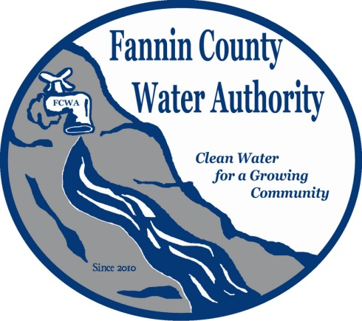
Fannin County Water Authority
Regular Monthly Meeting
Commissioners Meeting Room
November 15, 2017, 2:00 P.M.

Anita Weaver called the meeting to order 2:00 P.M.
Members present were Anita Weaver, Chairwoman, Larry Chapman, Vice-Chairman, Zack Ratcliff, Larry Atkins and David Falls. Jackie Self and Kay Kendall, Secretary were absent. A quorum was present.
Bids were opened for the sale of the Old Quarry Road property owned by the Fannin County Water Authority. The first bid from Cleaston Green Jr. was $225,000.00 with contingencies to move and pave the road. The second bid from TGF Properties was $276,000.00.
A motion was made by Larry Chapman to accept the bid from TGF Properties with proof of funds within 10 days and a closing date on or before December 31, 2017. David Falls seconded the motion. The motion passed unanimously.
A motion was made by Larry Chapman to approve the minutes from the Regular Monthly Meeting of the Water Authority held October 18, 2017 with a correction to the 7th paragraph on page 3 to read “offer to sell the Excavator”. Larry Atkins seconded the motion. The motion passed unanimously.
Marnie Mashburn, Administrative Assistant supplied a copy of the Actual vs. Budget report to all Board Members. Collections are being monitored closely with no issues. A request was made for a possible water connection at 2031 Lowery Road and an estimate made by Kurt McCord was supplied to all Board Members. The storage tank in the My Mountain Subdivision was last cleaned and inspected in December of 2015 with a cost of $2,000.00.
Kurt McCord with Carter & Sloope Consulting Engineers recommended that the storage tank be visually inspected first.
Dusty Stancil with T. Stanco Inc. reported that the River Crest Lane extension within the Riverwalk on the Toccoa subdivision is complete and the end of the line sample was will be taken to Ellijay for testing by the end of the day.
Kurt McCord reported that the plans are approximately 75% complete for the Blue Bird Road Extension and expect to have EPD approval by the December meeting. The inventory record was supplied by Marnie Mashburn which will help to determine what materials will be needed to complete the project.
A motion was made by Larry Atkins to pay invoice 17453 from RL Jennings & Associates, PC in the amount of $5000.00. Anita Weaver seconded the motion. The motion passed unanimously.
Marnie Mashburn reported that the first audit’s cost was approximately $25,000.00, last year’s audit expense was $19,275.00 and this year’s will be approximately $18,000.00.
A motion was made by Larry Chapman to pay invoice 22462 from Carter & Sloope Consulting Engineers in the amount of $11,725.00. Zack Ratcliff seconded the motion. The motion passed unanimously.
A motion was made by David Falls to pay invoice 22463 from Carter & Sloope Consulting Engineers in the amount of $11,892.50. Larry Chapman seconded the motion. The motion passed unanimously.
Larry Chapman suggested that the FCWA have a meeting in December due to all the projects in progress. The next Regular Monthly Meeting will be held one week early on Wednesday, December 13, 2017.

Chad Bowers spoke about their possible plans for the water connection at 2031 Lowery Road. This will serve Project Chimps. They would like a meter placed at the driveway so that they can tie-in and serve the facility. The facility includes three occupied buildings (with chimps) with plans of filling a fourth building by December 1, 2017. There is also one other larger structure that will be occupied in the future. The pressure and quantity needed is exceeding what the existing wells can provide. They plan on installing 5 to 7 small fire hydrants and a sprinkler system. They will also be using holding tanks to store water.
Kurt McCord discussed many options for this line extension with a minimum cost of $5900 with a meter placed directly across from My Mountain Road to a maximum of approximately $41,563.00 with a meter set at the driveway. Chad Bowers will contact the FCWA when they decide.
George Bienert, a Riverwalk on the Toccoa resident and FCWA customer thanked the FCWA for expediting the road repairs within the subdivision.
A motion was made by Larry Atkins to go into Executive Session to discuss real estate. Anita Weaver seconded the motion. The motion passed unanimously.
Coming out of Executive Session, no decisions were made.
A motion was made by Larry Chapman that the meeting adjourns. Larry Atkins seconded the motion. The motion passed unanimously.

_______________________________, Anita Weaver, Chairwoman

_______________________________, Kay K. Kendall, Secretary

