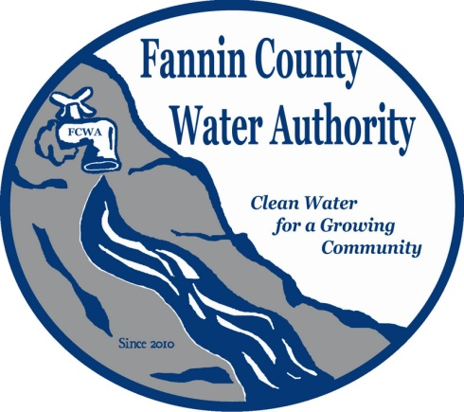
Fannin County Water Authority
Regular Monthly Meeting
Commissioners Meeting Room
October 18, 2017, 2:00 P.M.

Anita Weaver called the meeting to order 2:00 P.M.
Members present were Anita Weaver, Chairwoman, Larry Chapman, Vice-Chairman, Zack Ratcliff, Larry Atkins, Jackie Self and Kay Kendall, Secretary. David Falls was absent. A quorum was present.
A motion was made by Zack Ratcliff to approve the minutes from the Regular Monthly Meeting of the Water Authority held September 20, 2017. Kay Kendall seconded the motion. The motion passed unanimously.
Marnie Mashburn, Administrative Assistant supplied a copy of the Actual vs. Budget report to all Board Members. Collections are being monitored closely with no issues.
Kurt McCord with Carter & Sloope Consulting Engineers supplied a summary of the bids received for the Biennial Labor Contract. It is the recommendation of Carter & Sloope that T. Stanco, Inc. be selected based on the competitive pricing and the proven work history with Fannin County.
A motion was made by Kay Kendall to choose T. Stanco, Inc. as the Labor Contractor for the Fannin County Water Authority. Larry Atkins seconded the motion. The motion passed unanimously.
Kurt McCord supplied copies of Preliminary Cost Estimates for the Dry Branch Road extension at $206,570.00 and the Lake Cove extension at $324,884.50. There is a six-inch line within the Lake Cove subdivision that belongs to the City of Morganton. There are approximately 32 homes within the subdivision, but a survey will confirm how many residents are interested in connecting to the water system. The recommendation of Carter & Sloope is to look at other areas that are more easily accessible (extension of the existing systems) instead of having to invest in another Master Meter. Jackie Self explained that there will not be any SPLOST funds to use for the Dry Branch Road and Lake Cove extensions for at least 18 months. The FCWA Board decided to table the extensions until a later date.
A motion was made by Kay Kendall to close the GEFA checking account and transfer the remaining funds to the SPLOST checking account. Larry Atkins seconded the motion. The motion passed unanimously.
A motion was made by Kay Kendall to open a new SPLOST Account for the new SPLOST funding beginning October 2017. Larry Chapman seconded the motion. The motion passed unanimously.
A motion was made by Larry Chapman to have T. Stanco, Inc. begin the River Crest Lane extension within the Riverwalk on the Toccoa Subdivision. Kay Kendall seconded the motion. The motion passed unanimously.
Kurt McCord reported that work on the plans for the Blue Bird Road extension is in progress. Plans should be completed in December and then the permitting process will take approximately 2 months. The work should begin in March 2018. Tim Stancil with T. Stanco Inc. recommended that larger materials be kept on site, while smaller parts be kept in the FCWA storage building located at the Fannin County Barn.
Kurt McCord reported that material bids will need to go through the procurement process, like the labor bids. He recommended that the FCWA keep more stock on hand for small jobs and repairs.
A motion was made by Kay Kendall to reimburse Fannin County for Salaries and Fringe Benefits for the 3rd Quarter 2017. Larry Atkins seconded the motion. The motion passed unanimously.
A motion was made by Jackie Self to pay invoice 17433 from R. L. Jennings & Associates, PC in the amount of $5,000.00. Larry Chapman seconded the motion. The motion passed unanimously.
A motion was made by Larry Chapman to pay invoice 71018 from BSI Mechanical Sales and Service in the amount of $4,461.38. Kay Kendall seconded the motion. The motion passed unanimously.
George Bienert, a resident of the Riverwalk on the Toccoa Subdivision inquired about when repairs will be made to roads within the subdivision. He explained that Cross Creek Road needs repairs as soon as possible due to extra traffic traveling to the Pavilion for the upcoming events. Anita Weaver reported that the she has contacted the contractor who will complete the permanent repairs and they are working on a definite time frame.
A motion was made by Kay Kendall to go into executive session to discuss real estate and personnel. Zack Ratcliff seconded the motion. The motion passed unanimously.
Coming out of executive session, no decisions were made.
A motion was made by Larry Chapman to proceed with the Dry Branch Road extension. Kay Kendall seconded the motion. The motion passed unanimously.
A motion was made by Jackie Self to sell the Kubota Excavator for $42,000.00 and the 2015 Ford Work Truck for $20,000.00 back to Fannin County and lease them back on an as-needed basis. Larry Chapman seconded the motion. The motion passed. Zack Ratcliff abstained from voting.
No decisions were made on personnel.
A motion was made by Jackie Self to sell the property on Old Quarry Road owned by the Fannin County Water Authority with sealed bids starting at $160,000.00 and accepted in $1000.00 increments and will be advertised on the TVA website and the Fannin County Land Development website with all bids due in by 11/14/17 at 4:30 p.m. to the FCWA Administrative Office. Kay Kendall seconded the motion. The motion passed unanimously.
A motion was made by Larry Chapman that the meeting adjourns. Kay Kendall seconded the motion. The motion passed unanimously.

_______________________________, Anita Weaver, Chairwoman

_______________________________, Kay K. Kendall, Secretary

