Fannin County
Public Transportation System
Title VI Plan
2014

November, 2014
TITLE VI PLAN – TABLE OF CONTENTS

Introduction 3
Notice to the Public - Process 3
Title VI Complaint Process and Procedures 3
List of Title VI Investigations, Complaints or Lawsuits 4
Public Participation 4
Summary of Outreach Efforts 5
Language Assistance Plan 5
Membership of Non-Elected Committees and Councils 5
Monitoring of Sub recipients 5
Determination of Site or Location of Facilities 6
Resolution for Approval of Title VI Plan 6
Service Standards (for Systems under 50 vehicles) 6
Service Policies (for Systems under 50 vehicles) 7
TITLE VI APPENDIX A – TITLE NOTICE TO THE PUBLIC 8
TITLE VI APPENDIX B – TITLE VI COMPLAINT FORM 10
TITLE VI APPENDIX C – LANGUAGE ASSISTANCE PLAN 13
TITEL VI APPENDIX D – RESOLUTION BY THE BOARD 34

INTRODUCTION

As a direct recipient of Federal Transit Administration (FTA) funds, the Fannin County Board of Commissioners (BOC) is required to submit to a Title VI compliance report to the FTA Region office every three years. This document highlights the BOC’s efforts with regards to the Title VI compliance for its transit service. Annual updates are required by the FTA.

Title VI of the Civil Rights Act of 1964 prohibits discrimination on the basis of race, color or national origin in programs and activities receiving Federal financial assistance. Presidential Executive Order 13166 addresses services to those individuals with limited English proficiency. Presidential Order 12898 addresses environmental justice in minority and low-income populations. To address these federal requirements, the BOC has developed a Title VI Plan, a Limited English Proficiency Plan (LEP) and an Environmental Justice Plan. The following sections provide a summary of the BOC activities relating to those requirements.

NOTICE TO THE PUBLIC - PROCESS

The BOC’s goal is not to discriminate against any person with respect to any BOC transit program or service. This commitment is incorporated into all public outreach efforts to engage in all segments of the population in the transportation planning process. The BOC actively provides information regarding its Title VI obligations to the public using a variety of methods. Information, such as references to FTA and the BOC Title VI and LEP programs and complaint procedure is available upon request at the Transit office and at the BOC’s office and on the website. Notice of non-discrimination policy is included in all transit contracts, public meetings and bid advertisements. The BOC must certify each year that there have been no Title VI complaints or lawsuits.

As policy, staff is educated on the Title VI requirements including how to assist a person who has limited English proficiency. The entire FTA non-discrimination clauses are included in all consultant contracts and sub-grantee agreements. The Title VI Notice is shown in Appendix A and posted at the Fannin County Administrative Building, on the website, at the Transit Administrative Office and on all County transit buses.

TITLE VI COMPLAINT PROCESS AND PROCEDURES

Any person who believes she or he has been discriminated against on the basis of race, color or national origin by the Fannin County Board of Commissioners (hereinafter referred to as “The County”) may file a Title VI complaint by completing and submitting the agency’s Title VI Complaint form (Appendix B). The County investigates complaints received no more than 180 days after the alleged incident. The County will process complaints that are complete. Once the complaint is received, the County will review it to determine if our office has jurisdiction. The complainant will receive an acknowledgement letter informing her/him whether the complaint will be investigated by our office.

The County has 10 business days to investigate the complaint. If more information is needed to resolve the case, the County may contact the complainant. The complainant has 10 business days from the date of the letter to send requested information to the investigator assigned to the case. If the investigator is not contacted by the complainant or does not receive the additional information within 10 business days, the County can administratively close the case. A case can be administratively closed also if the complainant no longer wishes to pursue their case. After the investigator reviews the complaint, she/he will issue one of two letters to the complainant; a closure letter or a letter of finding (LOF). A closure letter summarized the allegations and states that there was not a Title VI violation and that the case will be closed. An LOF summarizes the allegations and the interviews regarding the alleged incident and explains whether any disciplinary action, additional training of the staff member or other action will occur. If the complainant wishes to appeal the decision, she/he has 30 days after the date of the letter or the LOF to do so.

A person may also file a complaint directly with the Federal Transit Administration, at FTA Office of Civil Rights, 1200 New Jersey Avenue SE, Washington, DC 20590.

List of Title VI Investigations, Complaints or Lawsuits

The County maintains a file for Title VI complaints, investigations and lawsuits. Over the last seven years, there are no known investigations, complaints or lawsuits.

Record of Title VI Complaints, Lawsuits and Investigations
Case # Date Received | Complaint | Status | Summary of Review and Action Taken
Complaints
1)
2)
Lawsuits
1)
2)
Investigations
1)
2)

PUBLIC PARTICIPATION

The County seeks out and considers viewpoints of all persons including low-income, minority, elderly, disabled, Limited English Proficiency (LEP), ethnic and religious groups in the course of conducting public outreach and involvement activities in regards to transit activities. The County utilizes the County organ and the County website to achieve this objective. Hopefully, in the future the County can pursue social media to expand its public outreach efforts.

Public Outreach methods or activities include:

  - Website: The County includes information on its website regarding transit activities and the Title VI Plan.

  - Public Meetings and Workshops: the County’s Board meetings are advertised in appropriate amount of time and the public is encouraged to participate.

  - County Organ: All activities and service issues are publicized in the County organ.

  - Surveys: The County conducts surveys of riders on its transit system. Surveys request feedback from the public on how better to serve their needs. Staff considers the needs of those who cannot read or write and will contact the rider and verbally read the survey and record the respondent’s comments.

SUMMARY OF OUTREACH EFFORTS
Throughout the year we transport elderly citizens to the Senior Center so they can participate in many different types of health education, exercise and hobbies.
Throughout the year we transport elderly low income citizens to the Senior Center for free meals.

Through the use of local media we advertise any and all changes to the services provided by the County transit system.

LANGUAGE ASSISTANCE PLAN

To provide meaningful access to the County’s transit programs and services the County’s Language Assistance Plan (LAP) is utilized to achieve this objective. It serves as a tool and guide for staff on how to recognize a person who may need language assistance and how to provide that assistance. The LAP Plan was developed pursuant to the Department of Transportation’s guidance and is attached as Appendix C.

MEMBERSHIP OF NON-ELECTED COMMITTEES & COUNCILS

Fannin County has no transit related committees. All decisions relating to the transit service are made by the Fannin County Board of Commissioners, an elected body.

MONITORING OF SUBRECIPIENTS

Fannin County does not have sub recipients.

Should Fannin County have sub recipients, the following monitoring mechanisms would apply:

- Yearly service surveys of riders/customers

- Periodic unannounced inspections/visits of the system routes and facilities

- A review of the contractors published Title VI policy

- Fannin County will review any complaint made by a citizen against the sub recipient to ensure necessary and appropriate action

To insure these tasks are completed a log is maintained and is available upon request.

DETERMINATION OF SITE OR LOCATION OF FACILITIES

Fannin County has not constructed any transit related facilities with FTA funding.

RESOLUTION FOR APPROVAL OF TITLE VI PLAN

Attached as Appendix D is a copy of the executed resolution of the Fannin County Board of Commissioners for the Title VI Plan.

SERVICE STANDARDS (FOR SYSTEMS UNDER 50 VEHICLES)

- List of types of vehicles (non-fixed route).

Vehicle Type | Quantity | # of Wheel Chairs | # of Seats
Goshen E Series
450 Cutaway
Goshen E – 350 Cutaway | 3 | 1 | 10

- Vehicle Headway Standards

Transit service operates throughout the County from 8:00 a.m. until 4:30 p.m., Monday through Friday. Demand response service operates based upon the scheduling of trips based upon rider need.

Scheduling involves, at least, a 24 hour notice, must be a County resident and within our hours of operation.

- On-time Performance Standards

For Fannin County’s demand response service, a vehicle is considered on time if it departs a scheduled trip no more than 5 minutes late. The on-time performance objective for demand response is 95% or greater.

For Fannin County, a vehicle is considered on time if it departs a scheduled time point no more than 5 minutes late. The on-time performance objective for buses is 95% or greater. Monitoring of standards is performed through the monthly operation report prepared by Transit Operator.

- Service Availability Standards (for each mode)

Fannin County’s service availability for demand response service is determined by federal regulations.

Fannin County will distribute its transit service to all residents in the County.

Service Policies (for Systems Under 50 Vehicles)

- Vehicle Assignment for Each Mode

Fannin County does not assign vehicles to routes or types of service based upon vehicle age or other factors. The assignment is made based upon ridership demands. Demand response vehicles are assigned by the size of the vehicle for the services needed.

TITLE VI APPENDIX A

TITLE VI NOTICE TO THE PUBLIC

TITLE VI – NOTICE TO THE PUBLIC
Fannin County operates its programs and services without regard to race, color, national origin, age, sex, religion, disability, familial or income status. Any person who believes he or she has been subjected to any unlawful discriminatory practice under Title VI may file a complaint with the Human Resources Director as the Fannin County Title VI Liaison.
Any person who believes that he or she has been subjected to discrimination or retaliation, from Fannin County’s administration of federally funded programs, may file a written complaint. Note: If the person filing a complaint believes he or she has been discriminated against by any other branch of the Fannin County Government, they are directed to contact the Fannin County Human Resources Director at (706) 632-2203. All written complaints received by the County are referred immediately to the GDOT’s Title VI Coordinator for processing in accordance with approved State procedures.
Written complaints or questions may be sent to:
Human Resources Director
Fannin County Government
400 West Main St
Suite 100
Blue Ridge, GA 30513

If information is needed in another language or accessible in another required format, please contact us at the above phone number and assistance will be provided.
Si necesita informacion en otro idioma o accesibles en otro format requerido, por favor contacte con nosotros en el numero de telefono arriba y se prestara asistencia.

TITLE VI APPENDIX B

COMPLAINT FORM (IN ENGLISH & SPANISH)

TITLE VI PROGRAM AND RELATED STATUTES
DISCRIMINATION COMPLAINT AGAINST FANNIN COUNTY
Name: | Telephone (home): |  | Telephone (work):
Address: |  | City, State, Zip Code:
Name of COUNTY Staff Person that You Believe Discriminated Against You:

Address: |  | City, State, Zip Code:
Date of Alleged Incident:

You were discriminated against because of:

Race Retaliation Sex Familial Status Religion

Color National Origin Age Disability Other
(Language)
Explain as briefly and clearly as possible what happened and how you were discriminated against. Indicate who was involved. Be sure to include how other persons were treated differently than you. Also attach any written material pertaining to your case.

Signature: |  | Date:

FORMULARIO DE QUEJA
CONDADO DE FANNIN
Nombre de la persona discriminada: | Nomero de Telefono  (residencia): |  | Nomero do Telefono  (trabajo):
Direccion de Residencia: |  | Cuidad, Estado y C digo Postal de Residencia:
Nombre de la persona que discrimin contra usted, y nombre de la dependencia (si lo sabes):

Direccion de la persona o dependencia que discrmin contra usted: |  | Cuidad, Estado y C digo Postal de la persona o dependencia que discrimin contra usted:
Fecha del incidente discriminatorio:

Causa de la discriminacion:

Raza Retaliacion Sexo Estado Civil Religion

Color de PielNacionalidadEdadImpedimento FisicoOtro

Explique claramente como sucedi la discriminacion y quienes participaron en ella. Incluya en su explicacion caulquier conocimiento que tenga de tratamiento diferente a otras personas. Adjunte cual quier otro escrito relacionado con su caso.

Firma: |  | Fecha:

TITLE VI APPENDIX C

Language Assistance Plan

Fannin County
Board of Commissioners

Language Assistance Plan
Approved November , 2014

Prepared by:
Fannin County Human Resources Department
400 West Main St
Suite 100
Blue Ridge GA 30513
Phone: (706) 632-2203
Fax: (706) 632-2507

Table of Contents

Introduction………………………………………………………………………………………………………………………………….16
Executive Order 13166…………………………………………………………………………………………………………………..16
Plan Summary……………………………………………………………………………………………………………………………….16
Four Factor Analysis………………………………………………………………………………………………………………………17
How to Identify an LEP Person who Needs Language Assistance……………………………………………………18
Language Assistance Measures……………………………………………………………………………………………………..18
County Staff Training…………………………………………………………………………………………………………………….19
Providing Notice of Available Language Service to LEP Persons……………………………………..……………..19
Monitoring and Updating LEP Plan…………………………………………………………………………………………..…..19
Dissemination of the County’s LEP Plan……………………………………………………………………………………..…20
LAP APPENDIX A Population Maps……………………………………………………………………………………………21
LAP APPENDIX B List of Available Resources………………………………………………………………………..…..28
LAP APPENDIX C Fannin County Discrimination Complaint Procedure (includes Program Participants attachment)…………………………………………………………………………………….……………………..…29
LAP APPENDIX D Notice to Fannin County Grant and Program Sub recipients………….………………33

Introduction
The purpose of this limited English Proficiency policy guidance is to clarify the responsibilities of recipients of federal financial assistance from the U.S. Department of Transportation (DOT) and assist them in fulfilling their responsibilities to limited English proficient (LEP) persons, pursuant to Title VI of the Civil Rights Act of 1964 and implementing regulations. It was prepared in accordance with Title VI of the Civil Rights Act of 1964, 42 U.S.C. 2000d, et seq., and its implementing regulations provide that no person shall be subjected to discrimination on the basis of race, color or national origin under any program or activity that receives federal financial assistance, and;
Executive Order 13166
Executive Order 13166 “Improving Access to Services for Persons with Limited English Proficiency,” reprinted at 65 FR 50121 (August 16, 2000), directs each Federal agency that is subject to the requirements of Title VI to publish guidance for its respective recipients clarifying that obligation. Executive Order 13166 further directs that all such guidance documents be consistent with the compliance standards and framework detailed in the Department of Justice’s (DOJ’s) Policy Guidance entitled “Enforcement of Title VI of the Civil Rights Act of 1964—National Origin Discrimination Against Persons with Limited English Proficiency.” (See 65 FR 50123, August 16, 2000 DOJ’s General LEP Guidance). Different treatment based upon a person’s inability to speak, read, write or understand English may be a type of national origin discrimination.
Executive Order 13166 applies to all federal agencies and all programs and operations of entities that receive funding from the federal government, including state agencies, local agencies and governments such as the County, private and non-profit entities and sub recipients.
Plan Summary
The Fannin County Board of Commissioners (County) has developed this Limited English Proficiency Plan (LEP) to help identify reasonable steps to provide language assistance for LEP persons seeking meaningful access to County programs as required by Executive Order 13166. A Limited English Proficiency person is one who does not speak English as their primary language and who has a limited ability to read, speak, write or understand English.
This plan details the procedures on how to identify a person who may need language assistance , the ways in which assistance may be provided, training staff, how to notify LEP persons that assistance is available, and information for future plan updates.
In developing the plan while determining the County’s extent of obligation to provide LEP services, the County undertook a U.S. Department of Transportation four factor LEP analysis which considers the following: 1)The number or proportion of LEP persons eligible in the County to be served or likely to encounter a County program, activity or service; 2)the frequency with which LEP individuals come in contact with a County program; 3)the nature and importance of the program, activity or service provided by the County to the LEP population; and 4)the resources available to the County and overall costs to provide LEP assistance. A brief description of these considerations is provided in the following section.
Four Factor Analysis
- The number or proportion of LEP persons eligible to be served or likely to encounter a County program, activity or service.

The County examined the US Census Bureau’s 2010-2013 American Community Survey (ACS) data and was able to determine that approximately 1.1% of the Fannin County population age 5 and older spoke a language other than English at home.

As the ACS survey indicates, of the 1.3% persons who spoke a language other than English, 1.1% speak Spanish or Spanish speak other Indo-European languages, less than 0.4% speak Asian and 0.4% speak Other languages.

Of the 1.1% of the persons that speak Spanish.

- The frequency with which LEP individuals come in contact with a County program, activity or service.
- The County assesses the frequency at which staff has or could possibly have contact with LEP persons. This includes documenting phone inquiries and surveying public meetings attendees. Since the last update, the County has recorded zero requests for an interpreter in any language and zero requests for translated County documents.

- The nature and importance of the program, activity or service provided by the Recipient to People’s lives

There is an extremely small concentration of Spanish speaking persons in Fannin County, however the County will evaluate the need for any formal outreach efforts to identify those County programs that would be of importance to a Spanish-speaking LEP person.

An on-board passenger survey was conducted to collect data on usage of and access to the Catoosa County Transit system. According to the survey, the most common age among all the participants in the survey was 65 or older. This supports the fact that Fannin County Transit system can be considered a senior transit service as most of its patrons are over the age of 65.

To further access personal mobility options, each respondent was asked how he or she would have made the surveyed trip had Fannin County Transit system not been available. The most frequent response was “friend or family member” (40 percent). An additional 25 percent indicated they would not have made the surveyed trip if the service was not available. This data indicates that the Fannin County Transit system is very important as a primary means of transportation for its customers.

- The resources available to the County and overall costs

Fannin County Transit system assessed its available resources that could be used for providing LEP assistance.

“I Speak” cards | No cost (access on-line)
Access to a Spanish Speaking Interpreter | When needed, $20/hour

After analyzing the four factors; the County developed the plan outlined in the following section for assisting persons of limited English proficiency.
Element 1: Identifying LEP Individuals who Needs Language Assistance
Below are tools to help identify persons who may need language assistance:
- Examine records requests for language assistance from past meetings and events to anticipate the possible need for assistance at upcoming meetings;
- Having Census Bureau Language Identification flashcards available at Fannin County Transit system meetings. This will assist Fannin County in identifying language assistance needs for future events and meetings.
- Having Census Bureau Language Identification flashcards on all transit vehicles to assist operators in identifying specific language assistance needs of passengers. If such individuals are encountered, vehicle operators will be instructed to obtain contact information to give to Fannin County Transit system management to follow up.
- Vehicle operators and front-line staff (i.e., dispatchers, transit operation supervisors, etc.) will be surveyed on their experience concerning any contacts with LEP persons during the previous year.
Element 2: Language Assistance Measures
When an interpreter is needed, in person or on the telephone, first determine what language is required. If the required language is not available or if a formal interpretation is required, staff shall use the telephone interpreter service, Language Line, at 1-800-752-6096 and this service is available 24 hours a day, 7 days a week. The following County documents are currently available in Spanish: the Title VI Discrimination Complaint Form.

Element 3: Training Staff
All Fannin County Transit staff will be provided with the LEP Plan and will be educated on procedures and services available. This information will also be a part of the County staff orientation process for new hires. Training topics are listed below:
- Understanding the Title VI LEP responsibilities;
- Use of LEP “I Speak Cards”;
- How to access an interpreter (in person or via telephone);
- Documentation of language assistance requests;
- How to handle a complaint

Element 4: Providing Notice of Available Language Service to LEP Persons

Post signs that language assistance is available in County buildings, transit vehicles and facilities, and other public places.

Outreach Techniques:

- If staff knows they will be presenting a topic that could be of potential importance to an LEP person or if staff will be hosting a meeting or a workshop in a geographic location with a known concentration of LEP persons, have meeting notices printed in an alternative language, such as Spanish.
- When running a general public meeting notice, staff should insert the clause, “Un traductordel idioma espanol estara disponible.” This means, “A Spanish translator will be available.” Or if not sure of the need, staff should insert this clause, “Si usted necesita la ayuda de untraductor del idioma espanol, por favor comuniquese con la Catoosa County al telefono 706-632-2203, cuando menos 48 horas antes de la junta,” which asks persons who need Spanish language assistance to make arrangements with the County within two days of the publication notice.

Element 5: Monitoring and Updating the LEP Plan

The plan will be reviewed and updated on an ongoing basis. At a minimum, the County will follow the Title VI Program update schedule for the LEP Plan. Updates will consider the following:

- How many LEP persons were encountered?
- Were their needs met?
- What is the current LEP population in Fannin County?
- Has there been a change in the types of languages where translation services are needed?
- Is there still a need for continued language assistance for previously identified County programs? Are there other programs that should be included?
- Have the County’s available resources, such as technology, staff and financial costs changed and are they sufficient to fund the language assistance resources needed?
- Were any complaints received?

Safe Harbor Provision

The Fannin County Transit system’s service area does have LEP populations which qualify for the Safe Harbor Provision. The Fannin County Transit System does not have LEP groups which speak English less than “very well” which exceeds either 5.0% or 1,000 persons.

Dissemination of the County Limited English Proficiency Plan

The County will post the LEP Plan on its website at: www.fannincountyga.org. Additionally, the Policy Statement and Complaint Procedure will be posted at the Fannin County Senior Center and the Fannin County Board of Commissioners Administration office. The Complaint Policy Statement and Complaint Procedure are also included in the Transit vehicles.

Any person, including social service, non-profit, law enforcement agencies and other community partners with internet access will be able to access the plan. For those without personal Internet service, the Fannin County library offers free Internet access. All Transit employees will also be educated on the importance of providing language assistance. LEP persons may obtain copies of the plan upon request.

Any questions or comments regarding this plan should be directed to the County Title VI Specialist:

Human Resources Director
Fannin County Board of Commissioners
400 West Main St.
Suite 100
Blue Ridge GA 30513

Phone: (706) 632-2203
Fax: (706) 632-2507

LAP APPENDIX A – POPULATION MAPS
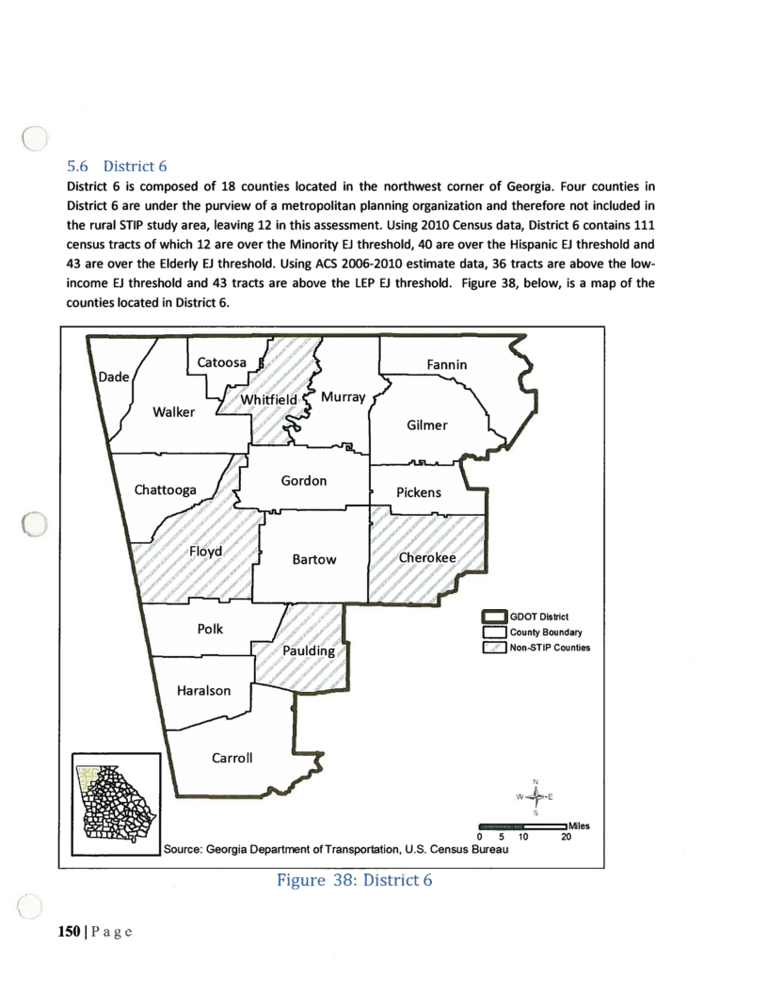
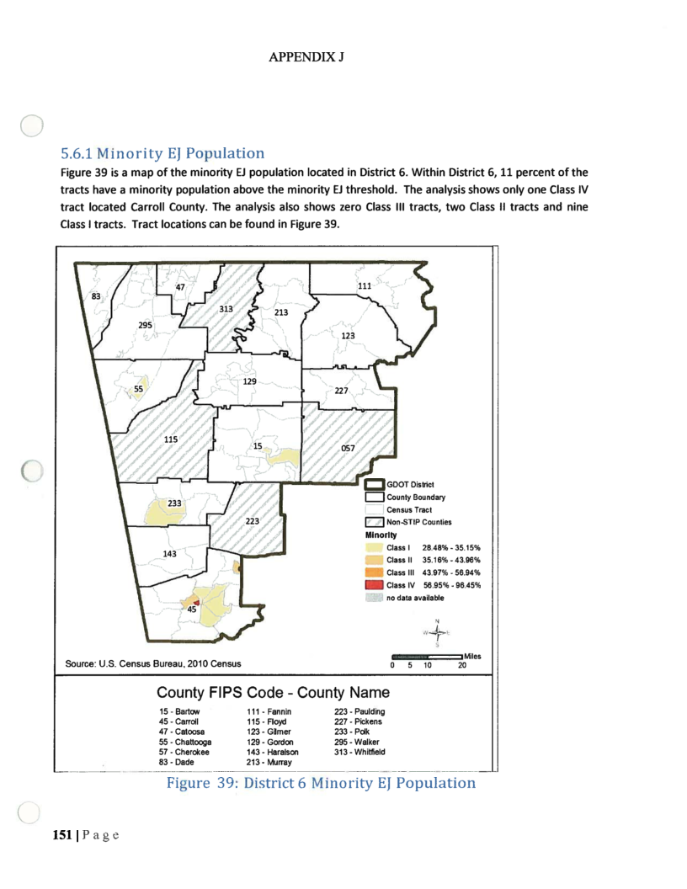
Fannin County has a minority population that is far less than the Class 1 percentages

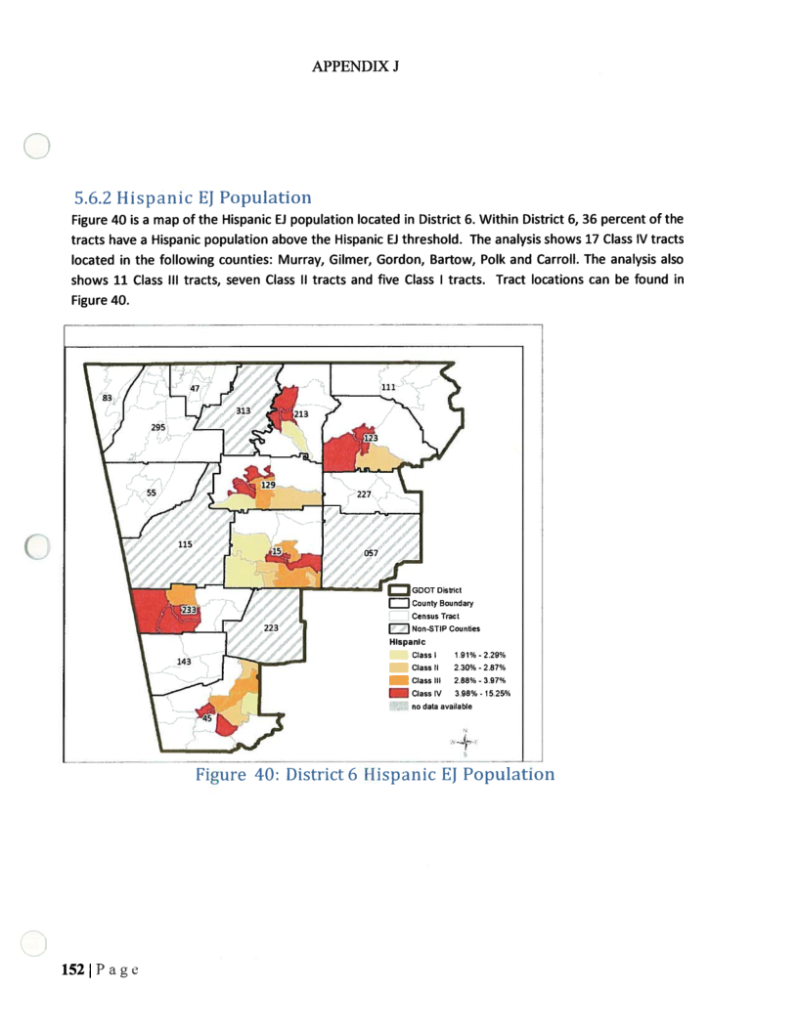
Fannin County has a Hispanic EJ Population of less than the Class 1 range of 1.91% - 2.29%

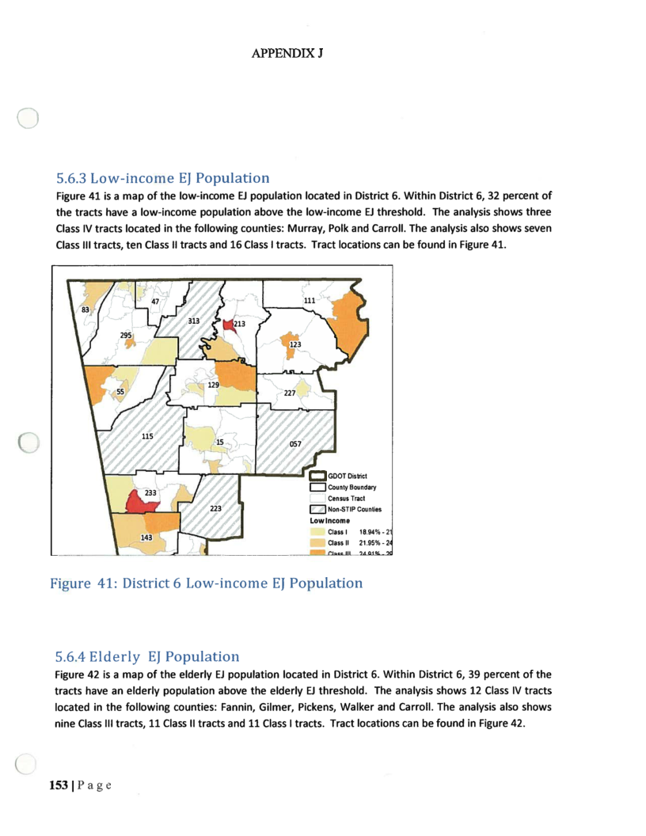
Fannin County only has an extremely small portion of the County that meets the Class 1 percentage of Low Income Population

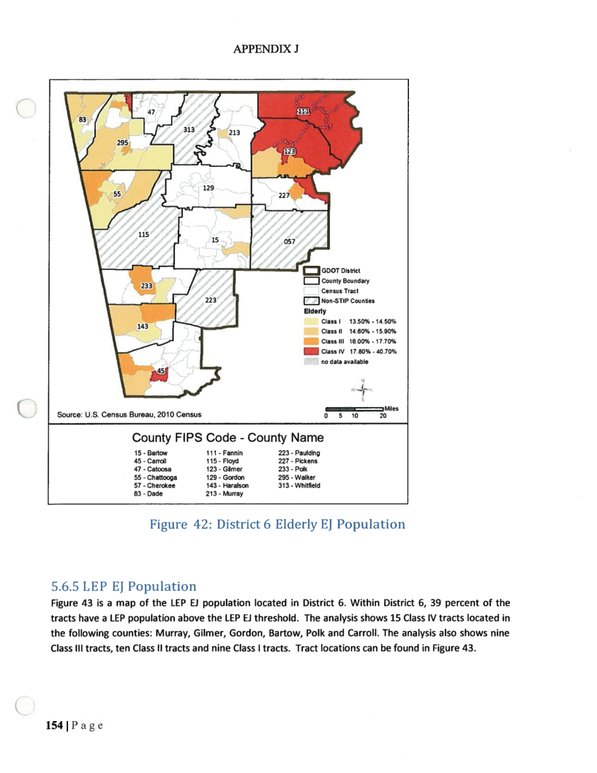
Fannin County has less than the Class 1 Elderly Population

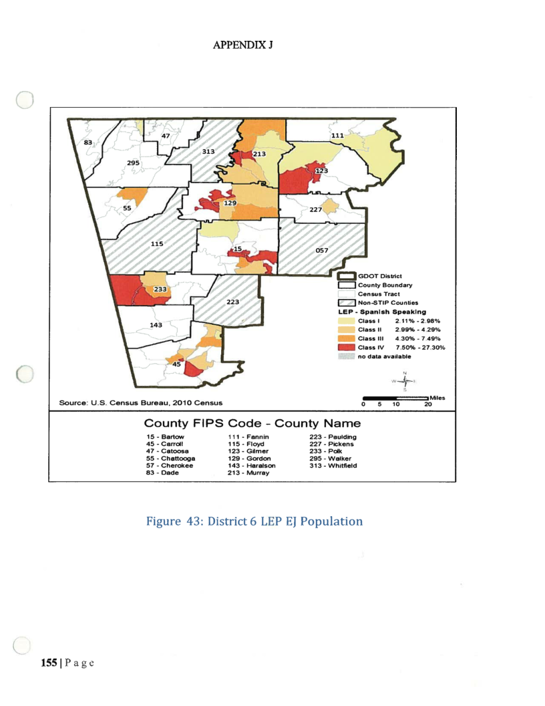
Fannin County has less than the Class 1 LEP EJ Population
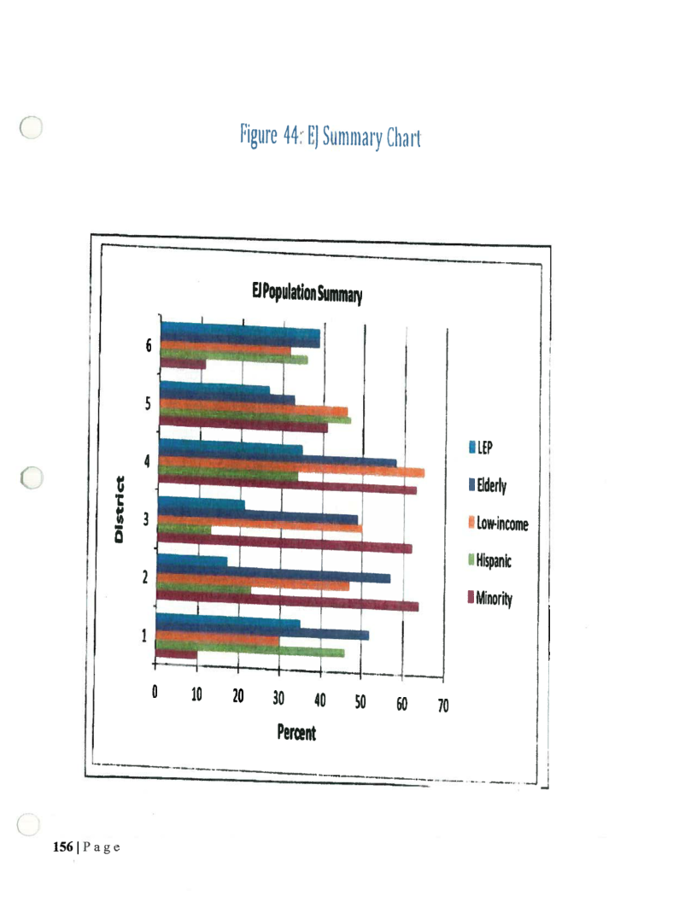

LAP APPENDIX B
List of Available Resources

If the required language is not available or if a formal interpretation is required, staff shall use the telephone interpreter service.
Formal Interpreter and Translation Service:
The County will utilize the Language Line Interpreter Services at 1-800-752-6096.
LAP APPENDIX C

Fannin County Discrimination Complaint Procedure

Title VI of the Civil Rights Act of 1964 as amended prohibits discrimination on the basis of race, color and national origin for programs and activities receiving federal financial assistance. As a recipient of federal financial assistance, the Fannin County Board of County Commissioners has in place a Title VI complaint procedure.

- Any person who believes that he or she, or any specific class of persons, has been subjected to discrimination or retaliation, from the Fannin County Board of Commissioners administration of federally funded programs, as prohibited by Title VI of the Civil Rights Act of 1964, as amended, and related statutes, may file a written complaint. All written complaints received by the County are referred immediately by the County’s Title VI Specialist, to the FTA’s Title VI Coordinator for processing in accordance with approved procedures.

Written complaints may be sent to:
Human Resources
Fannin County Board of Commissioners
400 West Main
Suite 100
Blue Ridge, GA 30513
Phone: (706) 632-2203

- The County’s Title VI Specialist shall resolve verbal and non-written complaints received by the County informally. If the issue has not been satisfactorily resolved through informal means, or if at any time the complainant requests to file a formal written complaint, the Complainant shall be referred to the FTA’s Title VI Coordinator for processing in accordance with approved procedures.

- The County’s Title VI specialist will advise the FTA’s Title VI Coordinator within five (5) calendar days of receipt of allegations. The following information will be included in every notification to the FTA’s Title VI Coordinator:

- Name, address and phone number of the Complainant;
- Name and address of the County;
- Basis of complaint (i.e., race, color, national origin, sex, age, disability, religion, familial status or retaliation);
- Date of alleged discrimination;
- Date complaint received by the County;
- A statement of complaint;
- If applicable, other agencies where the complaint has been filed;
- An explanation of the actions the County has taken or proposed to resolve the allegation(s) raised in the complaint.

- Within ten (10) calendar days, the County’s Title VI Specialist will acknowledge receipt of the allegation(s), inform the Complainant of action taken or proposed action to process the allegation(s), and advise the Complainant of other avenues of redress available, such as the FTA’s Equal Opportunity Office (EOO).

- Within sixty (60) calendar days, the recipients County Title VI Specialist will conduct and complete a review of the verbal or non-written allegation(s) and based on the information obtained, will render a recommendation for action in a report of findings to the County Manager.

- Within ninety (90) calendar days of the verbal or non-written allegation(s) receipt, the County Manager will notify the Complainant in writing of the final decision reached, including the proposed disposition of the matter. The notification will advise the Complainant of his/her right to file a formal complaint with the FTA’s EOO if they are dissatisfied with the final decision rendered by the County.

- The County’s Title VI Specialist will maintain a log of all verbal and non-written complaints received by the recipient. The log will include the following information:

- Name of Complainant;
- Name of Respondent;
- Basis of complaint (i.e., race, color, national origin, sex, age, disability, religion, familial status or retaliation);
- Date verbal or non-written complaint was received by the recipient;
- Date recipient notified the FTA’s Title VI Coordinator of the verbal or non-written complaint; and
- Explanation of the actions the County has taken or proposed to resolve the issue raised in the complaint.

TITLE VI PROGRAM AND RELATED STATUTES
DISCRIMINATION COMPLAINT AGAINST FANNIN COUNTY
Name: | Telephone (home): |  | Telephone (work):
Address: |  | City, State, Zip Code:
Name of COUNTY Staff Person that You Believe Discriminated Against You:

Address: |  | City, State, Zip Code:
Date of Alleged Incident:

You were discriminated against because of:

Race Retaliation Sex Familial Status Religion

Color National Origin Age Disability Other
(Language)
Explain as briefly and clearly as possible what happened and how you were discriminated against. Indicate who was involved. Be sure to include how other persons were treated differently than you. Also attach any written material pertaining to your case.

Signature: |  | Date:

FORMULARIO DE QUEJA
CONDADO DE FANNIN
Nombre de la persona discriminada: | Nomero de Telefono  (residencia): |  | Nomero do Telefono  (trabajo):
Direccion de Residencia: |  | Cuidad, Estado y C digo Postal de Residencia:
Nombre de la persona que discrimin contra usted, y nombre de la dependencia (si lo sabes):

Direccion de la persona o dependencia que discrmin contra usted: |  | Cuidad, Estado y C digo Postal de la persona o dependencia que discrimin contra usted:
Fecha del incidente discriminatorio:

Causa de la discriminacion:

Raza Retaliacion Sexo Estado Civil Religion

Color de Piel Nacionalidad Edad Impedimento Fisico Otro

Explique claramente como sucedi la discriminacion y quienes participaron en ella. Incluya en su explicacion caulquier conocimiento que tenga de tratamiento diferente a otras personas. Adjunte cual quier otro escrito relacionado con su caso.

Firma: |  | Fecha:

LAP APPENDIX D
Notice to County Grant and Program Participants
All programs and operations of entities that receive assistance from the federal government, including the County and its participants, must comply to the fullest reasonable extent for improving access to services for Limited English Proficient (LEP) persons.
Participants are encouraged to have in place written policies on the provision of interpreter and translation services.
I acknowledge that a copy of Fannin County’s Limited English Proficiency Plan has been provided to our organization and I have read the contents and fully understand the LAP Plan obligations and responsibilities.

__________________________________________ _______________________
Signature Date

__________________________________________
Organization

APPENDIX D

RESOLUTION OF THE BOARD

RESOLUTION
A RESOLUTION OF THE BOARD OF COUNTY COMMISSIONERS OF FANNIN COUNTY, GEORGIA, APPROVING THE FANNIN COUNTY TITLE VI PLAN AS AUTHORIZED BY THE FEDERAL TRANSIT ADMINISTRATION AND THE MOVING AHEAD FOR PROGRESS IN THE 21ST CENTURY (MAP-21), PUBLIC LAW 112-141.
WHEREAS, as the recipient of Federal Transit Administration (FTA) funding, Fannin County is required to maintain a Title VI program; and
WHEREAS, the 2014 Fannin County Title VI plan for transit operations was developed per FTA Circular 4702.1B to meet the new requirements as authorized in the Moving Ahead for Progress in the 21st Century Law 112-141; and
WHEREAS, FTA Circular 4702.1B requires each recipient of federal funding assistance to provide a copy of board minutes or a resolution demonstrating the board’s consideration, awareness, and approval of the contents of the Title VI plan.
NOW THEREFORE, BE IT RESOLVED by the Board of Commissioners of Fannin County, Georgia, that:
The above recitals are incorporated by reference into the body of this resolution and such recitals are adopted as findings of fact.
The Board of Commissioners of Fannin County approves the 2014 Fannin County Title VI Plan for transit operations as presented.
To the extent that there are typographical or administrative errors that do not change the tenor tone, or concept of this Resolution, this resolution may be revised without subsequent approval of the Board of Commissioners.
The Board of Commissioners authorizes the Board Chair to sign this Resolution on behalf of the Board.
ADOPTED by the Board of Commissioners of Fannin County, State of Georgia, this 16th day of September, 2014.
BOARD OF COMMISSIONERS
FANNIN COUNTY, GEORGIA
By:____________________________
Bill Simonds, chairman
ATTEST:
________________________________
Rita D. Kirby, County Clerk

