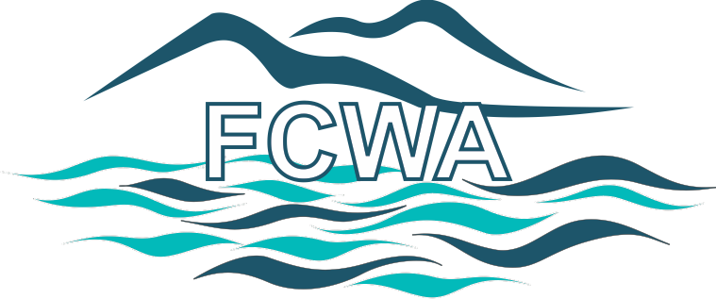

Fannin County Water Authority

February 14, 2024
The Fannin, County Water Authority will hold its regularly scheduled meeting on April 10, 2024 at the Fannin County Courthouse, 400 West Main, Blue Ridge, Georgia.
Following the regularly scheduled meeting, the FCWA will recess until 4:00 PM. At 4:00 PM, the FCWA will host a workshop as to possible areas for water expansion. Area property owners, citizens, developers and anyone interested in the expansion of public water are urged to attend.
For more information, call the Fannin County Water Authority at 706 258 5160 or
Email fcwa@fannincountyga.org.

